Transaction Acknowledgement and Rollback Implementation for LPMS
07th January 2014

Introduction/ Problem Statement:
Currently due to network connectivity issue at POS a transaction completion success message is not received. Due to which POS system does not understand whether the transaction was successful or not. This transaction does not get updated in POS and hence new doc no is not generated. Looking after this scenario, it is important to implement a transaction acknowledgement and Rollback system in CRM.

Workflow:

1. New API will be developed where POS system will send an acknowledgement flag along with docno. Refer below webservice call 2. CRM system will check whether transaction is available in system and update the transaction with acknowledgement flag 3. Docno will be moved into void docno for future references. 4. Transaction will be Roll backed 5. Points will be Roll backed. 6. After every 3 minutes, CRM system will search for such transactions where acknowledgement is not received and hence mark it as void transaction Webservice call
URL: / service/ transaction/acknowledge METHOD: POST or GET
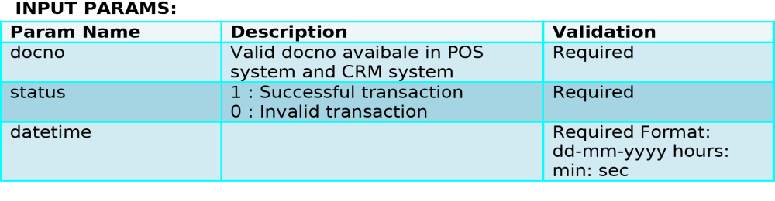
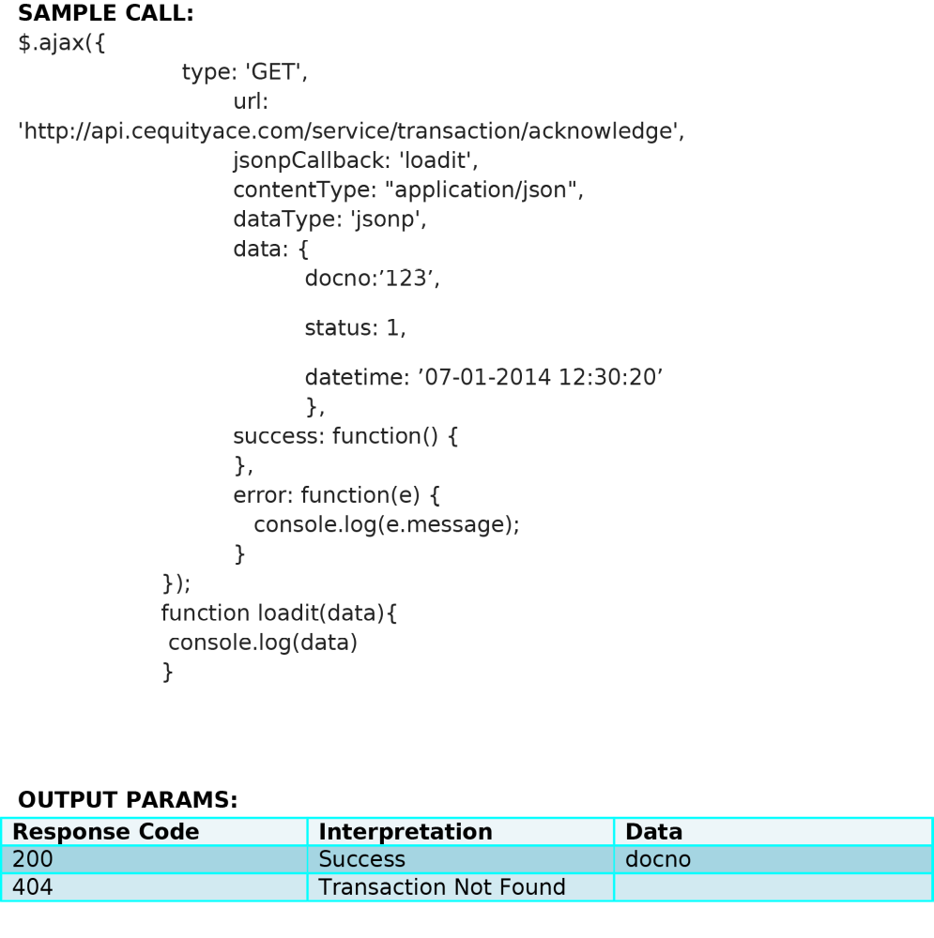
Assumptions
• Same POS terminal ideally should not send any new transaction for at least 3 minutes till the docno validity (based on acknowledgement call or timeout) expires.
• Any transaction being generated in period between response and acknowledgement or timeout with similar doc. no. will be considered as failure due to duplicate doc. no.

Impact
1. Rollback will affect below modules a. Referral point system b. Points system 2. Transaction call for checking duplicate doc no Known Issues:
1. Docno overlapping issue Case:
1. POS A sends transaction with Docno “test123” to loyalty engine
2. loyalty engine performs transaction and calculates points and send back success message
3. POS A receives this message and he updates the POS system
4. Now before sending acknowledgement for Docno “test123” , POS B sends transaction with same Docno “test123” to loyalty engine In between
5. As loyalty engine will checks for the duplicate docno along with acknowledgement flag, it will consider that Docno “test123” is failed transaction and completes the transaction
6. POS A sends acknowledgement to loyalty engine.
7. This will cause overlapping issue.

